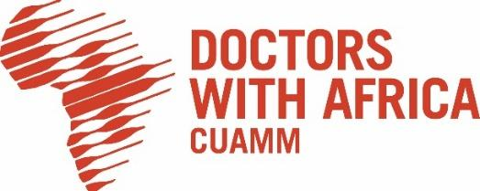LOCAL OPEN TENDER NOTICE
Supply of Medical Drugs, Laboratory Reagents, Medical Consumables and Medical Equipment
Ref. Nr-14/CUAMM/ETH/2026/ AID-13057/01/0

The International NGO, Doctors with Africa CUAMM, under the project titled “Integrated Humanitarian Response to Tigray Crises AID-13057/01/0”, is launching the present Local Open Tender to select eligible suppliers for the Supply of Medical Drugs, Laboratory Reagents, Medical Consumables and Medical Equipment.
Please find the complete tender dossier at the following link:

https://doctorswithafrica.org/en/get-involved/tender/supply-of-medical-drugs-laboratory-reagents-medical-consumables-and-medical-equipment/

or collect it at Doctors with Africa CUAMM main office at the following address:
Bole Sub-city, Woreda 3, House nr. 2434, Addis Ababa.

Tender offers can be delivered by hand-delivery or by post at the same address.
Tender submission deadline is JUNE,23,2026, 5 PM.

Please deliver all documentation listed in the – Check List.

The public tenders opening session will be held accordingly to the timetable provided in the tender dossier at Doctors with Africa CUAMM main office, Addis Ababa.

